Welcome to your new well-being program

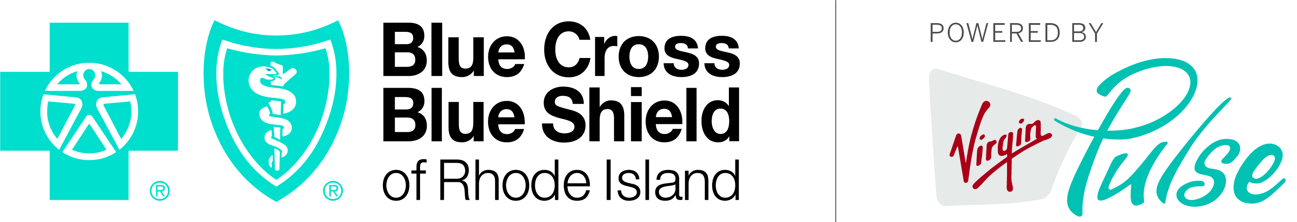

<First name>,

I’m pleased to announce that, in collaboration with Blue Cross & Blue Shield of Rhode Island, <COMPANY NAME> is launching an exciting and enjoyable program to help you improve your health and well-being.

This digital program gives you the tools, inspiration, and guidance you need to achieve your individual goals, right from your smartphone or computer. Measure your progress and keep track of the points you’ve earned by downloading the easy-to-use Virgin Pulse® app or visiting the website and select Blue Cross & Blue Shield of Rhode Island as your sponsor.

I hope you’ll give it a try. I think you’ll find this is a fun, fulfilling program, and it’s designed to help you succeed. You can earn points by learning how to manage your stress; getting information about healthy diets; or ramping up your physical activity through fitness challenges with co-workers.

There’s no cost to you and it’s easy to get up and running. The program will be launching in our workplace soon, so stay tuned for more information. The program is entirely optional, and does not impact your benefits under your Blue Cross & Blue Shield of Rhode Island health plan.

Sincerely,

<Leadership signature>

<First name> <Last name>

Program available to Blue Cross & Blue Shield members only.

Virgin Pulse® is an independent wellness company, contracted by Blue Cross & Blue Shield of Rhode Island to provide wellness services.
Blue Cross & Blue Shield of Rhode Island is an independent licensee of the Blue Cross and Blue Shield Association.

